CIS 450 - Project 1

By Marco Seman

Step one:

Inside the Linux VM, open a terminal, run the following commands:

cp -r xv6-public xv6

cd xv6

make

make qemu

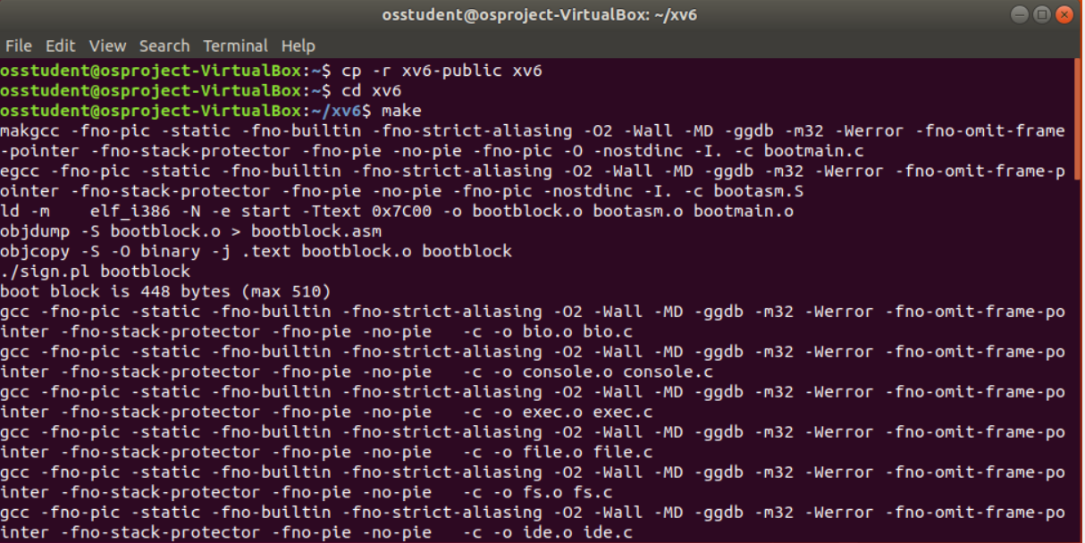

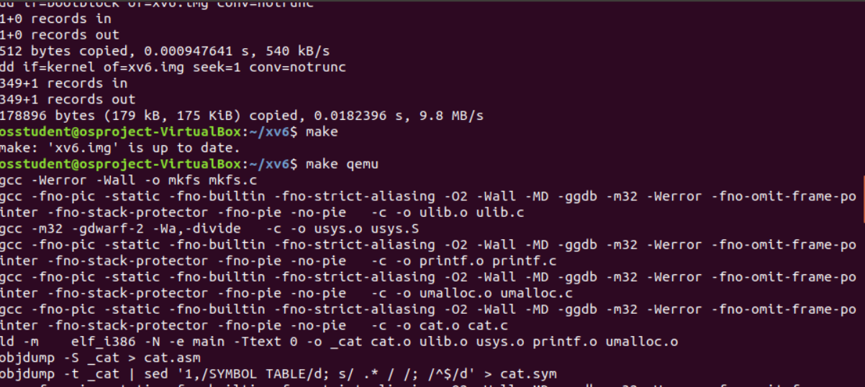

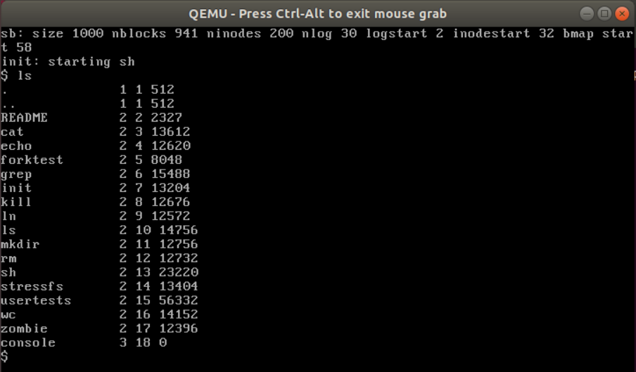

**Adding a new user program:**

Add into xv6 the first user program called hello.c, which is implemented as follows:

#include "types.h"

#include "user.h"

int

main(int argc, char *argv[])

{

printf (1, "Hello, my name is %s %s\n", argv[1], argv[2]);

exit();

}

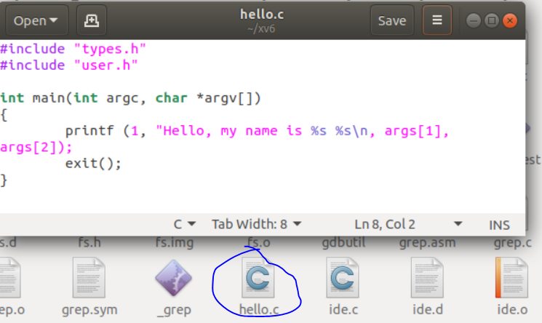

Add into Makefile this user program under UPROGS

UPROGS=\

3

_hello\

_cat\

...

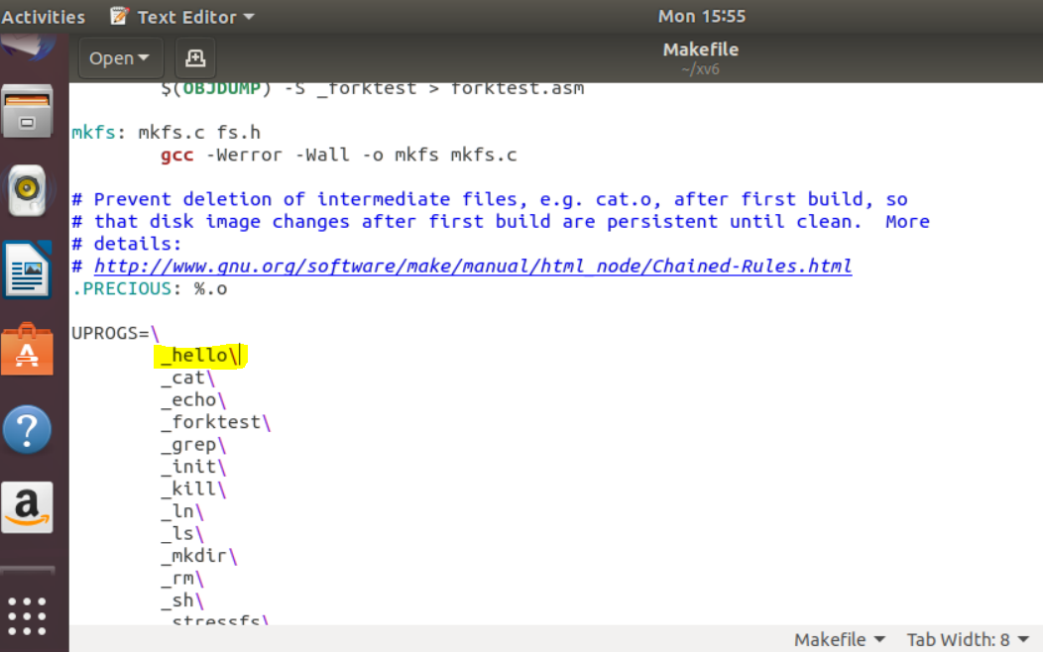

Then rerun the xv6 with the command, “make qemu”

Then you can test the new user program hello in the xv6 shell as follows:

$hello yourFirstName yourLastName

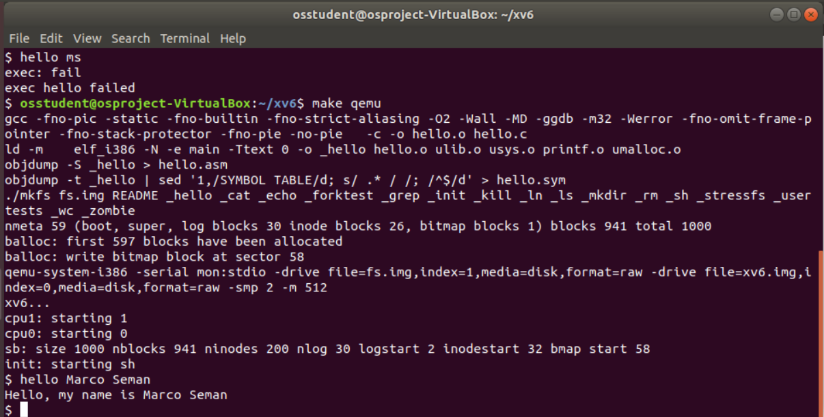

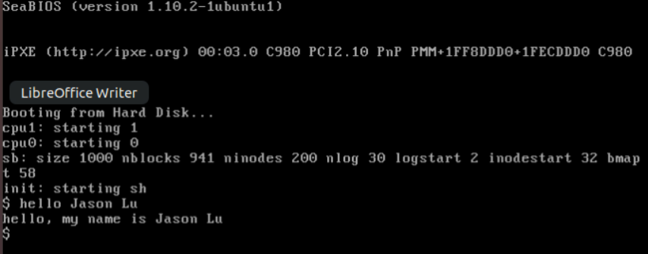

What we Learned

For our first project, we learned how to prepare a Linux virtual machine and install xv6 using the Unix terminal. For building the xv6, we learned the proper commands on how to properly copy the xv6-public and named it xv6 using the cp -r xv6-public xv6 command. We then went to the xv6 and installed and configured QEMU which is a generic open source machine emulator and virtualizer. In our next section, we learned how to create a C program using Unix by using text editer, writing the code, then saving the file with the extension of C. We then learned the proper place to locate the file inside the makefile in the xv6 directory in order for the terminal to find and read it. Finally, we learned how to properly execute the C file in the terminal and enter our input then receive the output.